SWT 22022 – Practical for Internet Application Development
Department of Information and Communication Technology
Faculty of Technology
Lab sheet :16
Reg. Number: SEU/IS/20/ICT/084
Academic Year :2020/2021
Date: 2024.10.14
Practical No :17

Title:
- HR Management System - III
Aims:
• Implement routes for views
• Implement views
Tasks:
• Update the APIs
• Update controller
• Create blade files

Activities :

1. Update the APIs
// For views
Route::get('employee/{id}/edit', [EmployeeController::class,
'edit']);
2. Update controller
public function edit($id) {
$employee = Employee::findOrFail($id);
return view('employee.edit', compact('employee'));
}
public function update(Request $request, $id)
{
$employee = Employee::findOrFail($id);
$employee->update($request->all());
return redirect('employee')->with('success', 'Employee updated successfully.');
}
public function delete($id) {
$employee = Employee::findOrFail($id);
$employee->delete();
return redirect('employee')->with('success', 'Employee deleted successfully.');
}
3. Create blade files
I. layout.blade.php
II. edit.blade.php

EmployeeController.php

<?php

namespace App\Http\Controllers;

use App\Models\Employee;
use Illuminate\Http\Request;

class EmployeeController extends Controller
{
public function index()
{
$employees = Employee::all();
return view('employee.index', compact('employees'));
}

public function create()
{
return view('employee.create');
}

public function store(Request $request)
{
$request->validate([
'name' => 'required|string|max:255',
'role' => 'required|string|max:255',
'salary' => 'required|numeric|min:0',
'age' => 'required|integer|min:18|max:65',
]);

Employee::create($request->all());
return redirect('employee')->with('success', 'Employee created successfully.');
}

public function edit($id)
{
$employee = Employee::findOrFail($id);
return view('employee.edit', compact('employee'));
}

public function update(Request $request, $id)
{
$employee = Employee::findOrFail($id);
$request->validate([
'name' => 'required|string|max:255',
'role' => 'required|string|max:255',
'salary' => 'required|numeric|min:0',
'age' => 'required|integer|min:18|max:65',
]);

$employee->update($request->all());
return redirect('employee')->with('success', 'Employee updated successfully.');
}

public function delete($id)
{
$employee = Employee::findOrFail($id);
$employee->delete();
return redirect('employee')->with('success', 'Employee deleted successfully.');
}
}

web.php
<?php

use App\Http\Controllers\EmployeeController;

// Employee Management Routes
Route::get('employee', [EmployeeController::class, 'index']);
Route::get('employee/create', [EmployeeController::class, 'create']);
Route::post('employee/store', [EmployeeController::class, 'store']);
Route::get('employee/{id}/edit', [EmployeeController::class, 'edit']);
Route::post('employee/{id}/update', [EmployeeController::class, 'update']);
Route::delete('employee/{id}', [EmployeeController::class, 'delete']);

layout.blade.php
<!DOCTYPE html>
<html lang="en">
<head>
<meta charset="UTF-8">
<meta name="viewport" content="width=device-width, initial-scale=1.0">
<meta http-equiv="X-UA-Compatible" content="ie=edge">
<link href="https://cdn.jsdelivr.net/npm/bootstrap@5.3.3/dist/css/bootstrap.min.css" rel="stylesheet">
<script src="https://cdn.jsdelivr.net/npm/bootstrap@5.3.3/dist/js/bootstrap.bundle.min.js"></script>
<title>HR Management System</title>
</head>
<body>
<div class="container">
@yield('content')
</div>
</body>
</html>

index.blade.php
@extends('employee.layout')

@section('content')
<div class="mt-5 card">
<h2 class="card-header">Employee Details</h2>
<div class="card-body">
<table class="table table-bordered">
<thead>
<tr>
<th>Name</th>
<th>Role</th>
<th>Salary</th>
<th>Age</th>
<th>Actions</th>
</tr>
</thead>
<tbody>
@forelse ($employees as $employee)
<tr>
<td>{{ $employee->name }}</td>
<td>{{ $employee->role }}</td>
<td>{{ $employee->salary }}</td>
<td>{{ $employee->age }}</td>
<td>
<a href="{{ url('employee/' . $employee->id . '/edit') }}" class="btn btn-warning btn-sm">Edit</a>
<form action="{{ url('employee/' . $employee->id) }}" method="POST" style="display:inline-block;">
@csrf
@method('DELETE')
<button type="submit" class="btn btn-danger btn-sm">Delete</button>
</form>
</td>
</tr>
@empty
<tr>
<td colspan="5">There are no employees.</td>
</tr>
@endforelse
</tbody>
</table>
</div>
</div>
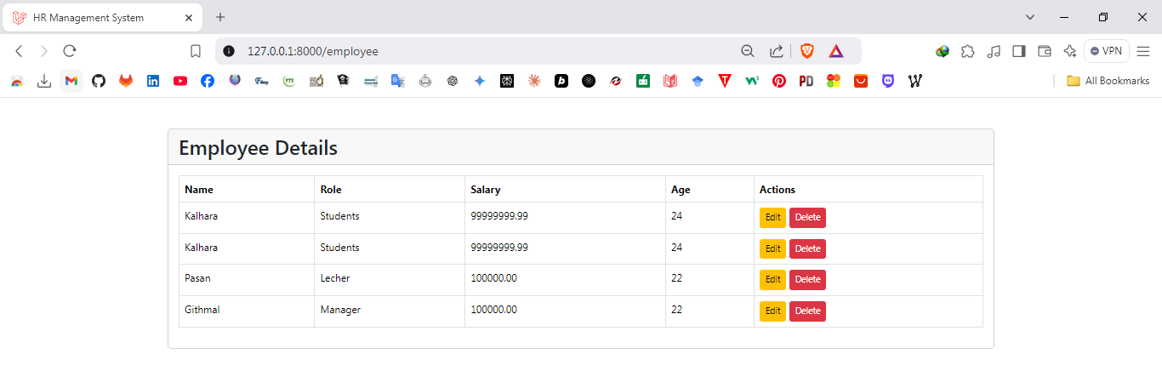
@endsection
create.blade.php
@extends('employee.layout')

@section('content')
<div class="mt-5 card">
<h1 class="card-header">Add New Employee</h1>
<div class="card-body">
<form action="{{ url('employee/store') }}" method="post">
@csrf
<div>
<label for="name" class="form-label">Name</label>
<input type="text" name="name" class="form-control" id="name" placeholder="Enter your name">
</div>
<div>
<label for="role" class="form-label">Role</label>
<input type="text" name="role" class="form-control" id="role" placeholder="Enter your role">
</div>
<div>
<label for="salary" class="form-label">Salary</label>
<input type="number" name="salary" class="form-control" id="salary" placeholder="Enter your salary">
</div>
<div>
<label for="age" class="form-label">Age</label>
<input type="number" name="age" class="form-control" id="age" placeholder="Enter your age">
</div>
<button type="submit" class="mt-2 btn btn-success">Add</button>
</form>
</div>
</div>
@endsection
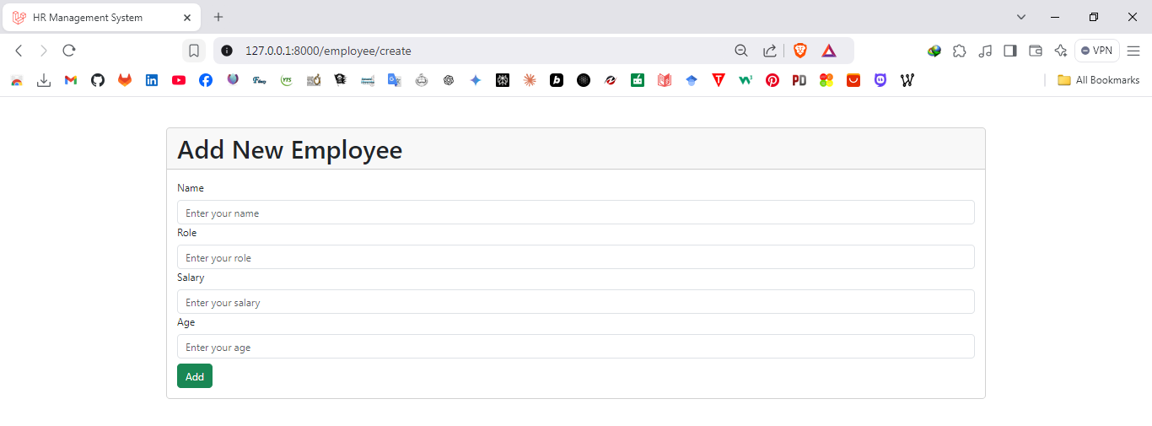

edit.blade.php
@extends('employee.layout')

@section('content')
<div class="mt-5 card">
<h1 class="card-header">Edit Employee</h1>
<div class="card-body">
<form action="{{ url('employee/' . $employee->id . '/update') }}" method="post">
@csrf
<div>
<label for="name" class="form-label">Name</label>
<input type="text" name="name" class="form-control" id="name" value="{{ $employee->name }}" placeholder="Enter your name">
</div>
<div>
<label for="role" class="form-label">Role</label>
<input type="text" name="role" class="form-control" id="role" value="{{ $employee->role }}" placeholder="Enter your role">
</div>
<div>
<label for="salary" class="form-label">Salary</label>
<input type="number" name="salary" class="form-control" id="salary" value="{{ $employee->salary }}" placeholder="Enter your salary">
</div>
<div>
<label for="age" class="form-label">Age</label>
<input type="number" name="age" class="form-control" id="age" value="{{ $employee->age }}" placeholder="Enter your age">
</div>
<button type="submit" class="mt-2 btn btn-primary">Update</button>
</form>
</div>
</div>
@endsection

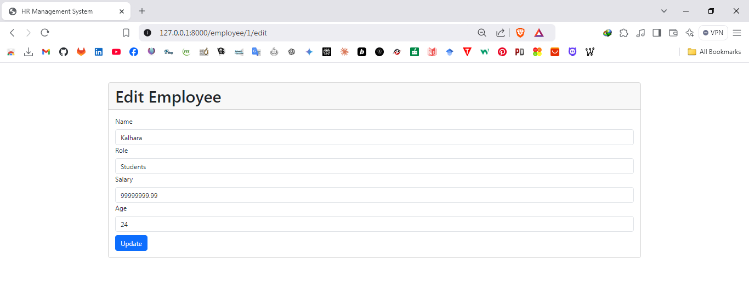
Discussion:
- In this lab session titled "HR Management System - III", we continued building our HR management application by focusing on creating a more dynamic and interactive user interface. The session aimed to strengthen our skills in Laravel by implementing routes specifically designed for views, such as editing, updating, and managing employees. We updated the APIs to ensure proper communication between the application layers and refined the controller logic to handle CRUD operations efficiently. Additionally, we developed new Blade files to enhance the visual representation and usability of the application. This hands-on practice allowed me to understand the integration between routes, controllers, and views while reinforcing my ability to implement scalable and maintainable code for real-world web applications.

